Kya Johnson
Gap Analysis Document
10/18/2025
IT 335

Table Of contents:
I: Executive Summary
II: Background, Scope, and Study Overview
A: Organizational Background
B: Scope
C: Approach
III: Gap Analysis and Results
A: Security Posture
B: Policy Errors and Gaps
C: Comparison analysis
D: Technological Analysis
IV: Recommendations
A: Findings
B: Policies
C: Defense
D: Controls
E: Implementation Plan
F: Policy Life Cycle

I: Executive summary:
This report was created to evaluate Wilber Widgets’ current security standing and identify any gaps and risks that threaten the systems and data. This analysis reviewed the policies and network infrastructure comparing it to ISO security standards. The goal was to assess how they protect their assets and provide recommendations for reducing risk in the company. The analysis shows weaknesses in operating systems, patching, policies. Training, and leadership. To strengthen their posture, they need to work on implementing stronger policies, better encryption and access controls, and enforce awareness and training. Leadership’s role will be most important in making sure any new and current policies are always enforced. Addressing these weaknesses will ensure that any risk is significantly reduced.
II: Background, Scope, and Study Overview
Organizational Background:
Wilber Widgets is a mid-sized manufacturing company that is the primary producer of the widget. It has 82 employees in total across different departments such as sales, manufacturing, inventory control, marketing, IT and HR. Currently this company does not feel that IT needs a larger budget and that information security is not worth the investment.
Scope:
In this evaluation we need to learn what policies are in place, what we need to add, and what needs to be updated to fit growing weaknesses. The company currently runs on Windows XP and does not have regular updates, so we need to decide what OS would be best and then implement more regular patches. Lastly employees do not know how to keep data safe by leaving documents and computers open, so we need to evaluate the training going on if any and implement a stronger one that will teach employees safe policies and make sure they understand why they are important.
Approach:
To analyze Wilber Widgets, I began by reviewing Wilbur Widgets Company Overview and identifying its current policies and background. I looked at what each policy addressed and what was missing, looking at the current problems to fully understand what needs to be implemented. Looking at the seven domains of IT infrastructure gave me gain a deeper understanding of what an organization requires to stay secure. And looking at the ISO standards provided me with best practices in risk management and access controls to see what improvements Wilber Widgets needs. Analyzing the companies’ current operations against external operations gave me a good view of what critical areas needed improvement.
III: Gap Analysis and Results
Security posture:
The security posture is at high risk and needs to be updated immediately due to outdated operating systems, lack of patching, and weak employee training. The company does not take security seriously enough and needs to focus on training, policies, and patches. As they do not see it as a good investment, we need to focus on explaining why and what will happen if they don’t keep up with security.
Policy Errors and Gaps:
After reviewing Wilber Widgets’ existing policies, it revealed many gaps and weaknesses in its security. It currently has a minimal set of policies including incident response, email, Bluetooth, router/switch, password construction, and information logging. With just these policies in place, they pose a serious risk to the companies’ systems and data. For example, they are currently running outdated operating systems without regular updates and no patch policy in place. Without updating the system regularly, known vulnerabilities are left accessible to any hacker. Next, employees leave documents unattended, and computers unlocked when they walk away showing no training policy in place. This allows insider threats to gain access to data that they shouldn’t have. Additionally, the lack of acknowledgement from leadership about the necessity of security shows that the existing policies are probably not be enforced as strongly as they should be. All together these gaps leave Wilber Widgets at risk to data loss, financial loss, or operational disruptions.
Comparison Analysis:
ISO standards emphasize a comprehensive, risk-based approach in security including governance, risk management, access controls, and asset protection. In contrast, Wilber Widgets has the minimal set of security policies that start the foundation for security, but they lack depth of coverage. With ISO, organizations must have outlined how data will be protected and how access controls will be put in place to keep data from unathorized people. Wilber widgets do not define data protection or access controls which go against ISO standards. ISO also requires secure configuration and patch management to be put in place and with Wilber Widgets operating on outdated and non-updated workstations they do not follow such standards. Lastly, ISO emphasizes the need for training and awareness for all users. Wilber widgets do not have any training in place and employees show no knowledge of security by leaving documents and workstations unattended.
Technological Analysis:
Wilber Widgets’ current technology has critical gaps in controls and guidelines that affect their security. To start, the organization is currently running outdated operating systems that no longer receive updates. This leaves the company open to attacks by known vulnerabilities with no updates happening to fix them. Additionally, there is no patching software or policies in place for regular updates. So, even when they do get new operating systems they will be at risk if they don’t provide regular updates to all systems and devices. Lastly, their network infrastructure lacks firewalls and monitoring devices that would be important in stopping and alerting attacks.
IV: Recommendations
Findings:
At the end of the analysis, it is clear Wilber Widgets security system lacks the necessary controls, technology, and policies to protect its assets. It is weak due to outdating operating systems, missing policies, lack of training, and lack of leadership support. The outdated operating systems leave every workstation vulnerable to known exploits. The lack of policies or training allows employees to be reckless with the companies’ data and technologies risking breaches or insider threats. And the lack of leadership involvement prevents IT from having the proper support they need to successfully protect the system.
Policies:
System security policy | Require all operating systems to be updated to the most current version and receive regular updates. Disable any unused services, enable firewalls and antivirus software.
3rd party policy | All third parties need to follow the policies set out by Wilber widgets. Should only have access to the resources needed for their job and use VPNs and encryption when communicating. All 3rd parties should have access to the system for as long as their contract states and no longer.
Access controls | Ensure employees can only access systems and data needed only for their job. And explains who has the right to change these controls.
Data handling and storage | Explains how sensitive data should be sent, stored, and disposed of. Necessary as employees leave documents unattended on their desks.
Training and awareness policy | Requires employees to go through security training and be made aware of any changes to security they must follow.
Encryption | Ensure employees are using encryption to send and store all sensitive data.
Patching policies | ensures all devices go through regular updates. Necessary as employees are not regularly updating their systems themselves.
Acceptable use policy | Explain how employees can use any system to reduce any further misuse.
Disaster recovery plan | Ensure a plan is in place in case of breach or outage so all employees know their role and operations can be up and running as soon as possible.
Monitoring and audits | Explains how logs are stored, reviewed, and investigated for misuse.

Acceptable use policy:
PURPOSE
This document establishes a policy for Wilber Widgets devices, systems, and assets.
BACKGROUND
This document was developed because the employees have demonstrated unsafe security practices while handling Wilber Widgets data such as leaving documents unattended on their desk and leaving their computer unlocked.
SCOPE
This policy applies to the use of all employees, 3rd-parties, and contractors who use Wilber Widgets system and data.
OPERATIONAL POLICY
4.1. Section 1 General use
All company resources are to be used only for business purposes.
Personal use permitted by special cases as long as it does not interfere with security.
4.2. Section 2 System security
All employees must ensure computers are locked when leaving their desk.
Users must not interfere with system security or install any unathorized software.
4.3. Section 3 Unacceptable use
Downloading or copying confidential data is prohibited.
Accessing a server or data for any other purpose then conducting business is prohibited.
4.4. Section 4 Internet and email use
Employees must use cation when opening email attachments from unknown senders.
Any form of harassment through email is prohibited
Sending unsolicited emails to individuals who did not request it is prohibited.
ROLES AND RESPONSIBILITIES
The following entities have responsibilities related to the implementation of this policy:
Management: Ensure employees complete training and follow policies.
HR Department: Ensure training records are tracked and maintained
IT Department: Provide security tools and monitor compliance
Employees: Follow policies and complete any training.
APPLICABLE LAWS/GUIDANCE
This policy supports best practices with NIST standards for information security and U.S. laws on data protection.
EFFECTIVE DATES
This policy becomes effective on the date that [xxx], Chief Information Officer (CIO), signs it and remains in effect until officially superseded or canceled by the CIO.
INFORMATION AND ASSISTANCE
Contact the IT Department for further information regarding this policy.
APPROVED
[Director of Information Security Policies] Date of Issuance: 9/28/2025
ASSOCIATED RESOURCES
This policy is augmented by:
Security Awareness and Training Policy
Incident Response Policy
Defense:
The policy recommendations proposed for Wilber Widgets are appropriate as they directly address the organization’s most critical risks. The system security policy will make sure operating systems are updated to supported versions and are given regular patches. The third-party policy makes sure any venders can’t steal or damage company assets. Training policies make sure all employees know how to keep data safe by not leaving it unattended on their desks and can recognize any social engineering attacks. Access controls make sure each department only has access to the resources they need. Data handling makes sure all employees know to use encryption and how to store data safely. These policies are essential for strengthening security and reducing human error.
Controls:
Purpose:
This document provides guidance and advice in explaining how Wilber Widgets will store data. This ensures that company data will remain safe and secure and consistent among all employees.
Audience
This document applies to all employees, contractors, and vendors with access to Wilber Widgets data on computers and servers.
Scope
This guidance applies to the storage of all of Wilber Widgets business data including sales, financial, marketing, and communications. This does not apply to employees’ personal data not related to Wilber Widgets.
Guideline Content
Local computer storage:
- All company data is to be stored in approved companies’ folders and servers and not on personal devices.
- All company data is to be encrypted and not left unprotected on computers.
- Computers are to be kept up to date and with strong password protection.
*These help with Wilber widgets as employees keep data unprotected and their computers unpatched
Cloud storage
- All company data stored on the cloud should be encrypted.
- Company data should only be stored on the cloud when permitted.
- Cloud data should only be accessed by authorized users and protected through MFA.
*This also helps Wilber widgets with employees keeping data unprotected by making sure when it is placed in the cloud it is protected and makes sure only authorized people can change or access it.
- Only authorized cloud services can be used.
Conclusion
Following this guideline will ensure Wilber Widgets data is protected from unauthorized access and tampering. By properly securing data on computers and the cloud, the organization can reduce the risk of loss within the company. All Employees are responsible for reading and following all guidelines stated.

Implementation plan:
Create urgency:
Wilber widgets current policies and practices put the company at an extremely elevated risk. The organization runs unpatched operating systems, employees lack serious training and often leave confidential documents out for anyone to see, and there are not strong policies in place for the employees to follow in case of breaches. These vulnerabilities make the company a target for attacks, accidental or intentional, that would cause the company to have extremely high loss and disruption. By taking care of this right away you save your company from financial or reputational loss that would be far more expensive than if you budgeted for it now.
Form a powerful coalition:
For these implementations to be successful, we will need support from leadership across departments. When leadership acts, employees are more likely to follow the new policies put in place. Leading by example is a great motto in this case, by showing employees that leaders are taking the new rules in place seriously and following them, employees will know that they need to take them seriously as well.
Create a vision for change:
Protecting our employees, company, and data is important to keeping Wilber widgets successful. By following these policies, you are ensuring that anybody’s info held within these walls is kept safe. And your job is ensured by the company following laws and regulations necessary to keep it going.
Communicate the vision:
Once policies are in place, they can be enforced with emails, posters, newsletters, and training. Things such as “check for updates” “remember to encrypt” “always lock your computer.” Keeping these messages consistent and visible to everyone will drill the new training for each employee and before they know it, they will be following security without even thinking about it.
Remove obstacles:
The main obstacle is funds, and with leadership on our side, we can gain the tools and training needed to ensure we enforce policies. Next will be employees that refuse to follow these new policies. They can be taken care of by ensuring the correct punishments are in place for not following security.
Create short-term wins:
Along with reminders in newsletters, there should also be successes added. If an employee successfully reports a phishing email or someone who is seen following all policies without issue can be shown as employee of the week. Giving incentive to other employees to be recognized for their hard work as well. Showing successful breach prevention can show leadership that the changes are working and will ensure that they continue to stand by them.
Anchor the changes in corporate culture:
This ties into the newsletters, the more encouragement leadership shows to the employees the more likely they will follow policies too. You can include training in staff meetings by starting the meeting off with reminders of safety or questions for staff to answer to ensure they understand. Over time, security will be just a normal thing employees do daily and will ensure these improvements last.

Policy Life Cycle:
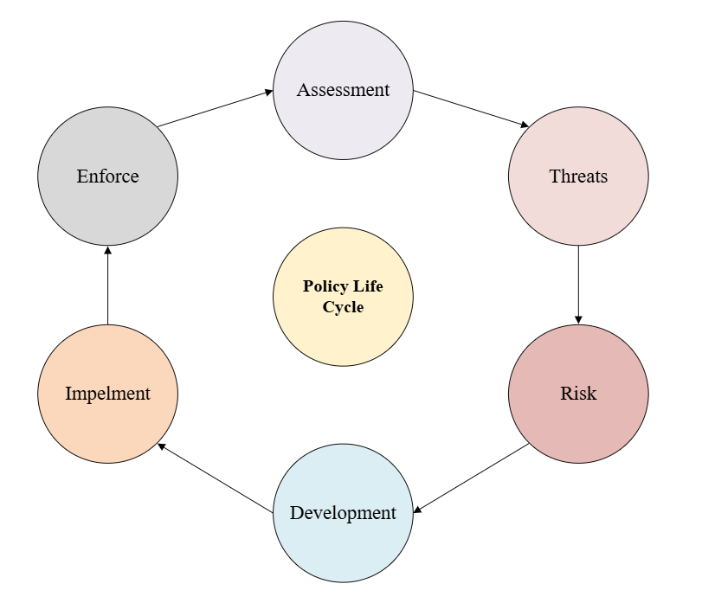

References:
Apptega. SECURITY AWARENESS AND TRAINING POLICY template. 65b0303d4fce38d350f54928_Security-Awareness-and-Training-Policy-Template-1.docx
Cohen, Fred; ISO17799 Policy Gap Analysis; SampleGapAnalysis.pdf
Compleye; What are the 7 IT domains?; What are the 7 IT domains? - compleye.io
Icims. Incident Response policy and procedures. Incident Response Policy & Procedures
Johnson, Robert; Easttom, Chuck (2022). Security Policies and Implementation Issues. Jones & Bertlett learning.
Kadam, A. (2022). Implementation Methodology for Information Security Management System. GIAC certificates. Implementation Methodology for Information Security Management System (to comply with BS 7799 Requirements)
Matish, A. (2024, March 14). Information Security Program Lifecycle: An ultimate Guide. Etactics. Information Security Program Lifecycle: An Ultimate Guide — Etactics
Scott, Andi; Spril 16, 2013; Computer Weekly; How to create a good information security policy; How to create a good information security policy | Computer Weekly
Wand, Dan; June 30, 2020; Securing the Seven Domains of IT Infrastructure; (1) Securing the Seven Domains of IT Infrastructure | LinkedIn

